Key Concepts and Highlights
- Governance in Cloud:
Cloud adoption changes resource provisioning dynamics. Unlike on-premises where an operations team mediates resource creation requests, cloud users (app owners) can provision resources directly. This necessitates automated guardrails (policies, RBAC, budgets) to ensure compliance with organizational and regulatory standards.
- Governance Goals:
Governance is primarily about risk mitigation—preventing data leaks, resource misconfigurations, security breaches, service interruptions, and reputational damage by enforcing policies regardless of how resources are provisioned.
- Shared Responsibility Model:
Microsoft manages certain compliance and security aspects, but customers remain responsible for protecting their data and controlling resource usage. Microsoft’s Trust Center and Microsoft Purview Compliance Manager provide extensive compliance certifications, reports, and tools to track organizational compliance posture, assign responsibilities, and manage improvement actions.

Core Azure Governance Constructs
Construct | Description | Key Points
Management Groups | Hierarchical containers to organize subscriptions. Root managment group + up to 6 levels deep child management groups, max 10,000 per tenant. Subscriptions under them. | Root Management Group exists per tenant; policies and RBAC applied here inherit downward, and upper management grp policy can be overridden by lower management grps.
Subscriptions | Basic unit of Azure billing and resource creation; trust a single Azure AD tenant | Unlimited subscriptions per tenant; can be organized flexibly; changing tenant is difficult
Resource Groups | Logical containers for resources sharing a lifecycle; flat structure within a subscription | Resources can be moved between groups/subscriptions; policies and RBAC can be applied here
- Inheritance is fundamental: Policies, RBAC, budgets, and locks applied at management group or subscription levels inherit down to resource groups and resources.
- Subscriptions should be organized thoughtfully but there’s flexibility; grouping by workload, business unit, environment, or geography is common.
- Resource Groups are not strict boundaries for resource interaction (e.g., networking can span groups), but help manage lifecycle and permissions. Region specified during RG creation is just where its metadata lives, and resources inside it can be from any region. RG can’t be renamed, but resources inside it can be moved to different RG or/and subscription.

Practical Example
Imagine a company with 50 subscriptions:
- Have a root management group.
- Under it, create child groups: Prod, Dev, Test.
- Place subscriptions under each group.
- Apply Azure Policy at the root (e.g., enforce tagging, restrict VM sizes).
- Assign RBAC at the Prod management group (e.g., Prod Admins = Owner).
- All subscriptions under Prod inherit those rules automatically.

Naming and Tagging Strategies
- Naming Standards: Essential for clarity and consistency across environments (on-premises and cloud).
Recommended pattern includes resource type, workload, environment, region, and instance number.
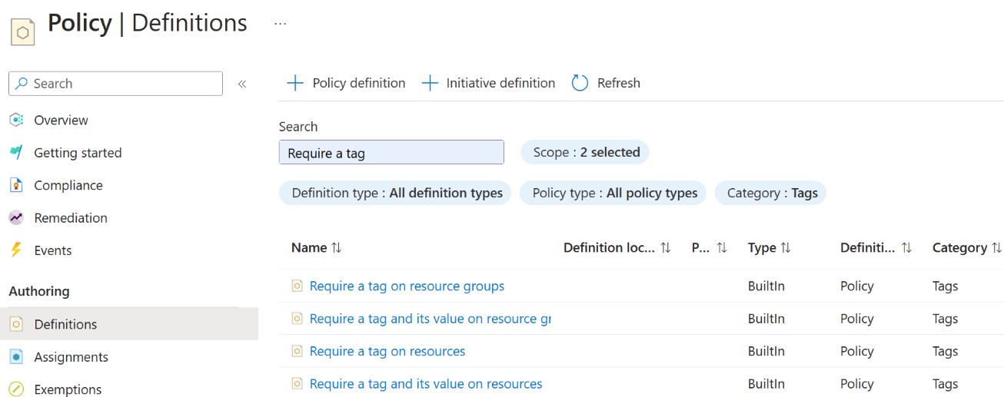
- Tagging:
  - Key-value pairs assigned at subscription, resource group, or resource level (not supported on management groups).
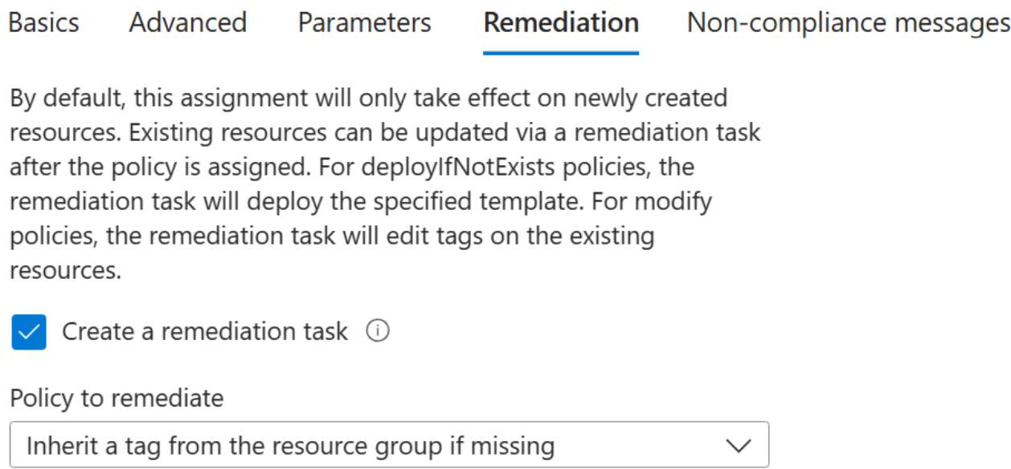
  - Tags are not inherited by default but can be inherited via Azure Policy (Policy definition: Inherit a tag from the resource group if missing ) for ease of management and cost allocation. Policy does not retroactively modify existing resources to add tags, only new resources. But can be done using remediation task.
  - Suggested core tags include business unit, cost center, app owner, environment, region, and owner.
  - Careful use of policies to enforce tagging is advised to avoid blocking automated deployments.

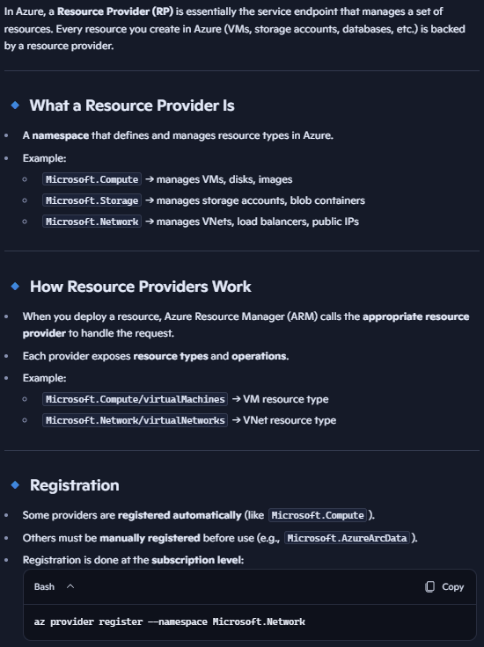
Access Control and Security
- Role-Based Access Control (RBAC):
  - Permissions granted at management group, subscription, resource group, or resource level.
  - Roles group related permissions (actions and data actions) for easier management.
  - Prefer granting permissions to groups, not individuals, to simplify administration.
Azure Resource Manager uses resource providers to offer various resources (like virtual machines, storage accounts) and define the actions that can be performed on them (e.g., read, write, delete, or specific actions like "run command extension").
  - Inheritance applies; no ability to block inherited permissions.
  - Supports custom roles (up to 5,000 per tenant) for least privilege scenarios.
  - Integration with Privileged Identity Management (PIM) enables just-in-time, eligible-only roles for enhanced security. PIM enables just-in-time access to elevated permissions for both Azure AD roles and Azure Resource Manager roles. This feature helps minimize standing access, requiring users to activate roles when needed, potentially with MFA, approval, or justification.
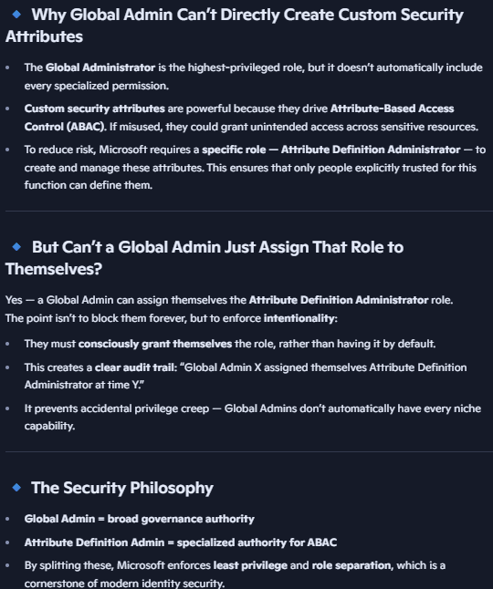
- Attribute-Based Access Control (ABAC):
  - Adds conditional access based on custom security attributes for identity and resource (e.g., we can create custom security attribute for project tags).
  - To create custom security attribute, user needs “attribute definition administrator” role. Global administrator is not enough. Then a created custom sec attribute with multiple predefined values can be created, which can be assigned to a user, and to a resource. If value matches, user has access.
  - Enables granular data access without creating excessive resource fragmentation.
  - Currently limited to certain data actions (e.g., blob storage) but expanding over time.
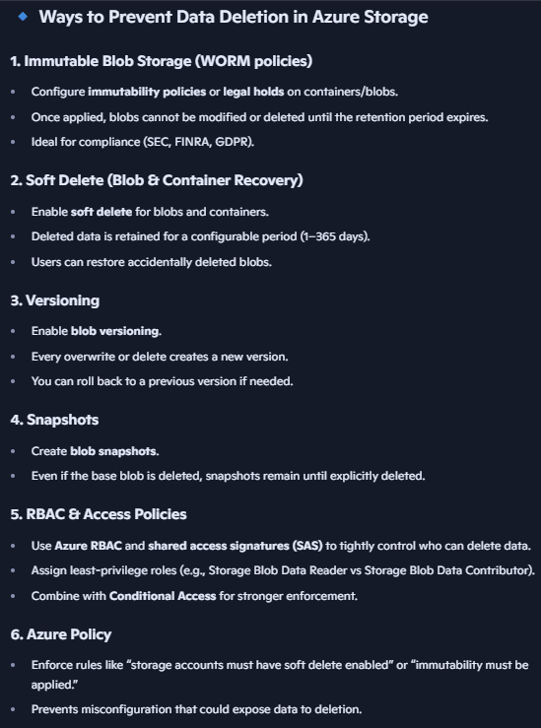
- Locks:
  - Applied at subscription, resource group, or resource level to prevent accidental deletion or modification.
  - Two types: Read-only and Delete lock (prevents deletion but allows modifications).
  - Locks apply to Azure control plane operations but do not protect data plane actions (e.g., deleting blobs). For preventing data deletion you have to use other ways like WORM, soft delete, RBAC, policy.

Azure Policy
- Sits on top of Azure Resource manager and any control plane operation has to pass through it. Central to governance for enforcing and auditing compliance with organizational rules.
- Policies evaluate resource property/attributes (exposed via aliases) and can enforce conditions like allowed regions, required tags, deny public IPs for subnet, or SKU restrictions.
- Supports multiple effects: Audit, Deny (eg. deny deleting a resource), Append/Modify (change resource while it’s being deployed), DeployIfNotExists, and Disabled.
- Policies are grouped into initiatives (policy sets) and assigned to a scope like RG/subscription, for managing complex compliance requirements (such as PCI DSS or FedRAMP – which are built-in initiatives).
- Policy inheritance follows the resource hierarchy, providing broad or granular control.
- Exceptions and exclusions can be configured at assignment time.

Cost Management and Budgeting
- Cost Analysis: Provides insights into spending patterns with customizable views and machine learning-driven smart insights to detect anomalies.
- Budgets: Set financial or resource quantity thresholds with flexible filters (tags, resource types) and actions (notifications, webhooks, Azure Functions). Can set as per actual or forecasted costs.
- Cost Allocation: Enables splitting shared resource (like express route or domain controllers) costs proportionally or evenly across business units or subscriptions.
- Supports exporting data for external analysis and integrating with Power BI and APIs.
- From a billing perspective resources can inherit tags for logical calculation and grouping. (it wont actually write those tags to the resources)
- Pricing calculator - The Azure Pricing Calculator is Microsoft’s official tool for estimating the cost of Azure services before you deploy them. It’s especially useful when planning workloads like VMs, storage, networking. Lets you select services (VMs, Storage, Databases, Networking, etc.).
Configure parameters (region, instance size, OS, redundancy, storage type).
Shows estimated monthly costs based on your configuration.
Allows you to compare options (e.g., different VM sizes or storage tiers).
Provides exportable estimates (Excel or PDF) for budgeting and procurement.

Cost Optimization Tools and Mechanisms – can see the below mechanism discounts in pricing calculator.
Mechanism | Description | Key Details
Azure Reservations | Pre-purchase discounted capacity for 1 or 3 years on specific VM sizes and regions | Discounts up to ~63%; commitment to pay regardless of usage; no capacity guarantee (so not guaranteed you’d be able to create vm at all times – so not really a reservation on capacity but reservation on prepaid cost to avail extra discount)
Azure Savings Plans | Flexible compute discounts across multiple compute services and regions | Lower discount (~31-54%) but covers more service types; no specific SKU or region locking
Azure Hybrid Benefit | Use existing licenses (Windows, SQL Server) to reduce Azure resource costs | Applies to OS and SQL licenses; reduces license charges on VM billing
On-Demand Capacity Reservations | SLA-backed capacity reservation for critical workloads requiring guaranteed resource availability | Paid continuously; allows guaranteed provisioning in specific region and SKU; used alongside reservations to block capacity as well.
- Understand commitment and flexibility trade-offs; reservations provide best discount but require specificity, savings plans offer flexibility.

Additional Governance Tools and Concepts
- Deployment Stacks: a resource in Azure Resource Manager that lets you manage a group of resources as a single unit. It builds on ARM templates or Bicep files, tracks the state of deployed resources, and allows you to update, detach, or delete them consistently. It’s essentially Azure’s evolution of Blueprints (deprecated), giving you Terraform-like lifecycle control but fully integrated into Azure. Enables lifecycle management of resource collections in single resource group OR subscription (resources can be spread across multiple resource groups) OR Management group (resources can be spread across multiple subscriptions and resource groups). Its is a lifecycle boundary for resources which will be created together and deleted together. Can add or remove resources from it anytime. Supports locking and denial policies for resource modifications or deletions within the stack.
- Azure Resource Graph:
  - High-performance query engine for inventory and configuration management across subscriptions. Can’t make changes using it.
  - Supports Kusto Query Language (KQL) for powerful queries and integrates with portal (Azure Resource Graph Explorer), CLI, and PowerShell.
  - Includes resource configuration changes tracking for auditing and troubleshooting. Upto 14 days.
- Azure Advisor:
  - Provides ongoing recommendations for cost optimization, security, reliability, and performance.
  - Allows creating alerts and digest reports to proactively manage the cloud environment.

- Entra RBAC controls who can create or manage identities (e.g., service principals, managed identities).
- Resource RBAC controls what those identities can do inside Azure resources.
Aspect | Entra RBAC | Azure Resource RBAC
Scope | Directory (tenant-wide) | Subscriptions, resource groups, resources
Objects Controlled | Identities, apps, policies | VMs, storage, databases, networking
Examples | Global Admin, User Admin | Owner, Contributor, Reader
Purpose | Manage identities & security | Manage workloads & data

Azure Active Directory (Azure AD) has its own separate set of roles, distinct from Azure Resource Manager roles, but a Global Administrator in Azure AD can elevate their privileges to manage Azure resources.

✈️ Control Plane (Azure Resource Manager)
- What it is: The orchestration layer that decides how resources should be provisioned and managed.
- Roles & Permissions:
  - Governed by Azure Resource RBAC.
  - Example: A user with Contributor role at subscription scope can create a VM.
  - The control plane checks RBAC before allowing the operation.
- Scope: Subscription, resource group, or resource.
- Key Point: Control plane RBAC decides who can issue commands that change resource state.

🛠️ Management Plane (Portal, CLI, REST APIs)
- What it is: The interface layer where admins/users interact with Azure (Portal, CLI, SDKs, REST).
- Roles & Permissions:
  - Also governed by Azure Resource RBAC.
  - Example: A user with Reader role can log into the portal and view resources but cannot modify them.
- Key Point: Management plane RBAC controls who can configure, monitor, or govern resources.

📦 Data Plane (Actual Resource Access)
- What it is: The execution layer — where workloads and data flow.
- Roles & Permissions:
  - Uses Azure Resource RBAC, but often with resource-specific roles.
  - Example:
    - Azure Storage: Storage Blob Data Reader role allows reading blobs.
    - Azure SQL: SQL-specific roles (separate from ARM RBAC).
  - These permissions govern who can read/write the actual data inside the resource.
- Key Point: Data plane RBAC decides who can use the resource’s data or workload.

📊 Side-by-Side
Plane | Role/Permission Scope | Example RBAC Role
Control Plane | Resource creation/config | Contributor, Owner
Management Plane | Portal/API visibility/config | Reader, Contributor
Data Plane | Resource-specific data access | Storage Blob Data Reader, SQL DB roles
